Madras Institute of Technology, Anna University

Department of Computer Technology

Project Completion Report for Phase I

Batch: 8/8 CSE ‘S’

**Project Title**: Crop Recommendation System using Machine Learning Techniques.

**Domain**: Machine Learning, Image Processing.

**Project Members**:

1. S. Krishna Prasad **2.** B. Sivasreedharan **3.** S. Jaishanth

**Guide:** Dr. P. Varalakshmi

|  |  |  |  |  |
| --- | --- | --- | --- | --- |
| Phase 1 Modules | Deliverables | Guide Comments | Signature of Guide | Marks |
| Image Denoising | Noise reduced satellite image |  |  |  |
| Image Segmentation | Classification with green NDVI as parameter in SVM |  |  |  |

**SYSTEM DESIGN:**

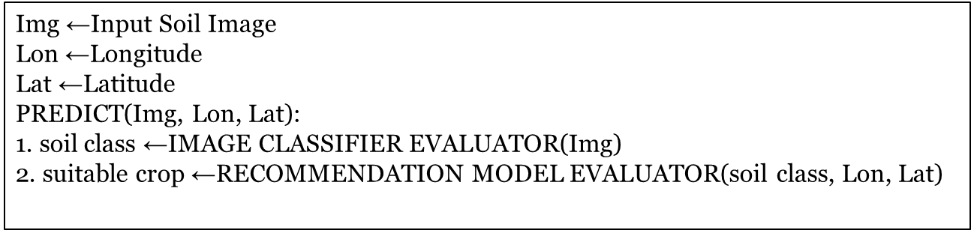

**NDVI- NORMALIZED DISTRIBUTION VEGETATION INDEX:** The normalized difference vegetation index (NDVI) is a simple graphical indicator that can be used to analyse remote sensing measurements and assess whether the target being observed contains live green vegetation or not.

**IMAGE DENOSING:** The unmixing model explicitly takes into account both Gaussian noise and sparse noise. The unmixing problem has been formulated to exploit joint-sparsity of abundance maps. A total-variation-based regularization has also been utilized for modeling smoothness of abundance maps. The split-Bregman technique has been utilized to derive an algorithm for solving resulting optimization problem.

**IMAGE SEGMENTATION:** The pre-processor uses the package OpenCV to segment the images by forming contours. This works by finding the possible contours with the specification to identify the soil areas. Then the image is segmented by keeping track of the formed contour areas.

Will any of the Phase I Modules be used or extended for Phase II? **Yes**

|  |  |  |  |  |
| --- | --- | --- | --- | --- |
| Phase 1 Modules | Need for Incorporating in Phase II | Guide Comments | Signature of Guide | Marks |
| Image Segmentation | Enhancing the NDVI accuracy in line with the crop classifier system |  |  |  |